**Office 365 for Students**

**Resetting Your Office 365 Account Password**

**1.** Go to: **accounts.umsystem.edu**in a web browser.

    Enter you S&T SSO and Password and **click 'Log in'**

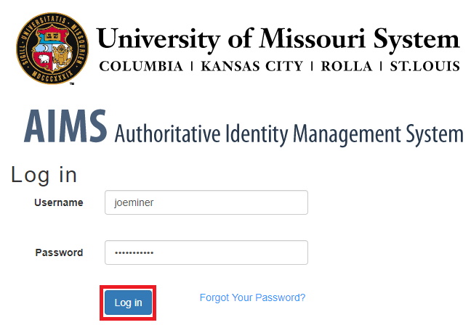

**2.**Locate the 'Office 365 Account' panel and **click 'Reset Office 365 Password'**

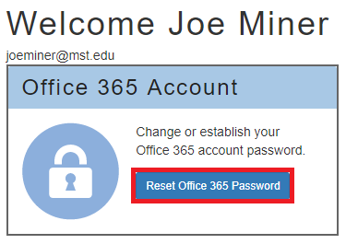

**3.**Enter a new password and **click 'Submit'.**

***NOTE:****This will only reset your Office 365 account password and****not****your S&T password.*

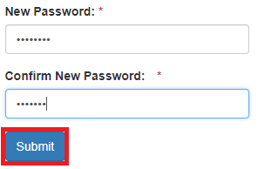

**4.**AIMS will now reset your Office 365 password.



**5.**Once it is complete, it should show you a success message.

***NOTE:****Do not click the link in the success notice.*

*Password Reset Successful*

**Installing Office 365**

**1.**Go to **portal.office.com** in a web browser.

    Enter your username **followed by '@mail.mst.edu'**and **click 'Next'.**

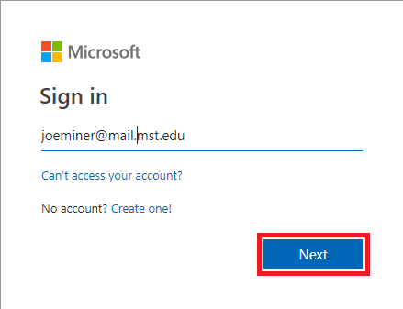

**2.**Enter the password that you just set in AIMS and **click 'Sign In'.**

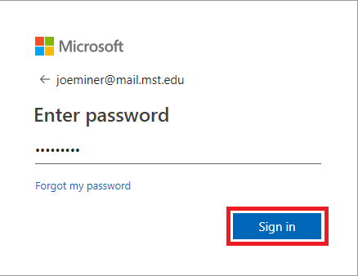

**3.**If prompted, **click 'Work or school account'**

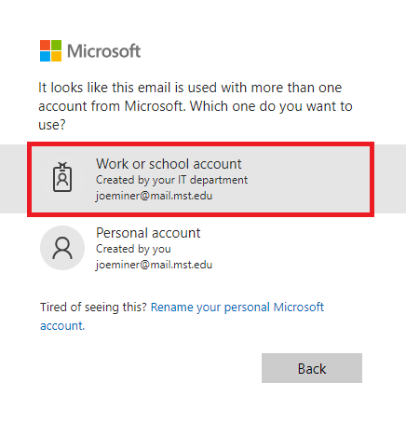

**4.**You will now be taken to your dashboard. **Click 'Install Office apps'.**

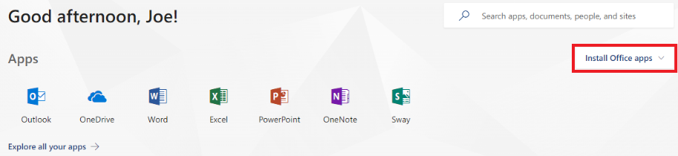

**5. Click 'Office 2016'.**

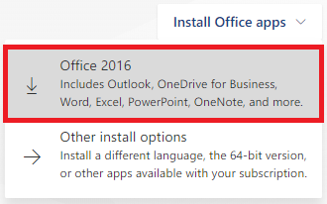

**6.**Run the installer that your browser starts downloading and follow the on screen instructions.

For assistance or to check the validity of this message, please contact the IT Help Desk by calling 573-341-4357 (HELP), visiting the IT Help Desk on the first floor of the library, or submitting a ticket online at [http://help.mst.edu](http://help.mst.edu/)

Information Technology  
Website: [it.mst.edu](http://it.mst.edu/)  |   IT Help Desk 573-341-4357   |   Online help request [help.mst.edu](http://help.mst.edu/)  
IT Help Desk, first floor of Curtis Laws Wilson Library